# **Nihat Rashidli**

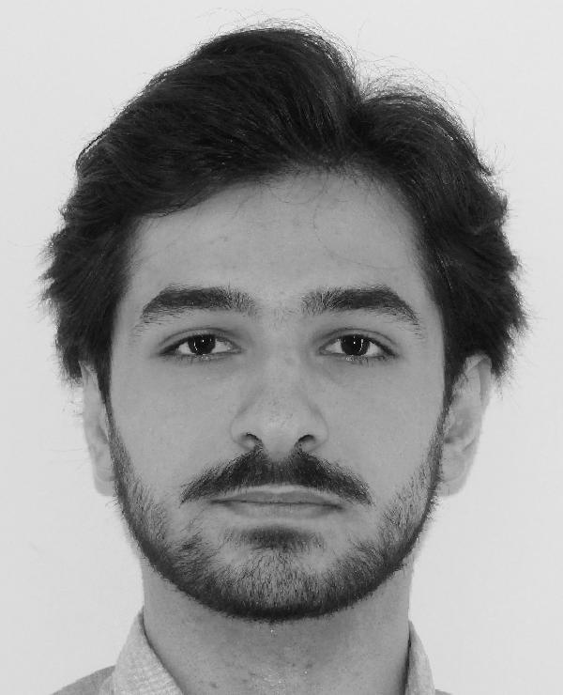

***Phone***:

+994556080015

***Email***:

nihatresidli36@gmail.com

***Address***:

Baku/Azerbaijan

# Qualifications

My passion for information technologies will create a solid foundation for successfully delivering projects. Got excellent public speaking and teamwork skills.

# Education

### **Azerbaijan Technical University**

## Information Technologies Sep. 2022 — Present

Third year student of bachelor`s degree.

I am studying at Code Academy for one semester.

# Work experience

## **Formula 2024 Grand Prix** 12.Sep 2024 — 15.Sep 2024

## *Volunteer*

## Assisted in event coordination, providing support to international guests and ensuring smooth operations during the event.

## **LaQuzu Restaurant** August 2024 — Sep. 2024

## *Waiter*

## I worked as an also waiter in LaQuzu restaurant for 1 months, Provided high-quality service to customers, ensuring the proper delivery of food and beverages.

## **Bomond Restaurant** May 2024 — July 2024

## *Waiter*

## I worked as an waiter in Bomond restaurant for 2 months, during this time I learned how to communicate properly and work with team.

## **Bir Könüllü Təşkilatı** Feb. 2024 — Feb. 2024

### *Volunteer*

## I provided the service of welcoming the athletes who came to Baku for 1 week and staying with them in the hotel and solving their problems during the organization of the Baku Grand Slam tournament that took place in Azerbaijan on February 16-18, 2024 under the organization of “Bir Könüllü Təşkilatı”.

## *Volunteer*

## I have participated in organizing football matches in both domestic and external leagues in Azerbaijan and one UEFA Conference league game.

## **Vigu Events** Aug. 2023 — Present

### *Crowd Management*

I worked as a manager of a concert organization. It further improves my ability to work with people. I participated in the concerts of many famous singers that took place in Baku.

# Certificates and Languages

Sep.2024 – Formula 1 Azerbaijan Grand Prix 2024 Volunteer Certificate

Apr.2024 – English language certificate İntermediate level

Feb. 2024 – for active participation in the organization of the Baku Grand Slam 2024 tournament

Turkish – Native

Azerbaijani – Native

English – İntermediate